Full title of the paper
(Times New Roman, size 15, single line, center alignment)

Nguyen Van A^{1,}, Dao Duy B², Tran Thanh C²
(Times New Roman, size 10, single line, spacing 6pt, center alignment)
¹ Hanoi University of Mining and Geology
² Vietnam National Coal and Mineral Industries Holding Corporation Limited
(Times New Roman, size 10, italic, single line, spacing 0pt, center alignment)

ABSTRACT (Maximum 300 words)
The authors should give the purpose and scope of research; applied methods and the main results achieved.
(Times New Roman, size 10, single line, spacing 0pt, justify alignment, first line 0.5cm).

Keywords: 4 to 6 keywords are given (Separated by semicolons, Times New Roman, size 10)

- Introduction (Times New Roman, bold, font size 10, single line spacing, 6 pt spacing before/after, automatic section numbering)
An overview of the research problem, the existing issues that have not yet been resolved, a summary of the main tasks carried out in the study, and the principal results achieved.
(Times New Roman, font size 10, single line spacing, 0 pt paragraph spacing, justified alignment, first-line indent 0.5 cm).
- Theoretical Background and Research Methodology (Times New Roman, bold, font size 10, single line spacing, 6 pt paragraph spacing, automatic section numbering)
- Content 1 (Times New Roman, bold and italic, font size 10, single line spacing, 6 pt paragraph spacing, justified alignment, automatic section numbering)
The text should be presented in Times New Roman, font size 10, single line spacing, 0 pt paragraph spacing, justified alignment, with a first-line indent of 0.5 cm.
Table citations (if any) should follow these rules: all tables must be numbered, and their titles, printed in italics, should be placed above the tables and centered. Tables should be prepared using applications that allow further editing. For example:
Table 1. Results of interpolation calculations for different alternatives
Check point | Reference elevation (h*) (m) | Elevation h calculated from GPS, EGM2008 model, and interpolated values
Check point | Reference elevation (h*) (m) | Collocation interpolation | Kriging interpolation
Check point | Reference elevation (h*) (m) | Collocation interpolation | k=0,25 | k=0,35 | k=0,5 | k=0,65 | k=0,75
1 | 907,976 | 907,990 | 907,985 | 907,988 | 907,988 | 907,988 | 907,989
2 | 296,987 | 296,863 | 296,829 | 296,839 | 296,854 | 296,856 | 296,858
Equations should be created using the MathType tool or the Equation feature in Word and numbered consecutively on the right-hand side. For example:
$Δζ_{i}=H_{i}-h_{i}-N_{i}$, (i=1,2...n) (1)
where:
H_{i} - ellipsoidal height of GPS points in the WGS-84 system;
h_{i} - leveling (orthometric) height determined in the national height system;
N_{i} - geoid height at the coincident point (taken from the geoid model);
n - number of coincident points.
Units: the International System of Units (SI) is used.
- Content 2 (Times New Roman, bold and italic, font size 10, single line spacing, 6 pt paragraph spacing, justified alignment, automatic section numbering)
- Content 2.1 (Times New Roman, italic, font size 10, single line spacing, 6 pt paragraph spacing, justified alignment, automatic section numbering)
The text should be presented in Times New Roman, font size 10, single line spacing, 0 pt paragraph spacing, justified alignment, with a first-line indent of 0.5 cm.
- Content 2.2
.............
- Results and Discussion
This section summarizes the experimental results and does not address their implications. The data are presented in the form of tables, graphs, figures, images, etc. This section aims to interpret and analyze the results, highlighting their advantages and limitations, clearly distinguishing between data and inference, and clarifying the relationship between the authors’ findings and those reported in previous studies.
Figures: All figures must comply with technical drawing standards. Each figure must be numbered consecutively, and its title, printed in italics, should be placed below the figure and centered. Papers that include regional or national maps must follow accurate and current standard formats and include a scale bar. All figures must be clearly numbered and annotated with sharp, legible captions. The required resolution is 300 dpi for continuous-tone color figures, 800 dpi for line drawings, and 700 dpi for mixed figures. For example:
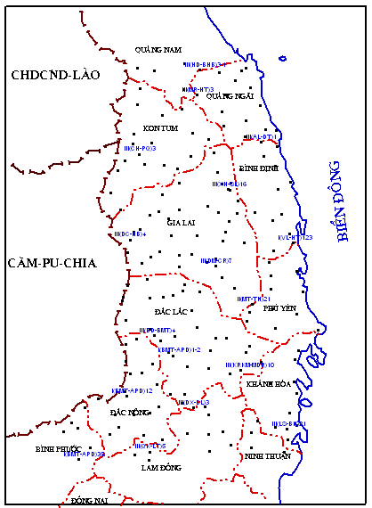
Figure 1. GPS–Leveling coincident points
- Conclusions
This section summarizes the main results obtained and proposes directions for further research or recommends applications of the research findings.
Acknowledgements (if any)
The authors acknowledge the contributions of organizations and individuals who helped to complete the study.
References
References are placed immediately after the Conclusions section of the paper and are arranged in alphabetical order according to the surname of the first author. The specific formats for each type of reference are as follows:
Journal articles: Author name(s), year of publication. Title of the article. Journal title (in italics), volume (issue), pages from … to …
Conference papers: author name(s), year of publication. Title of the paper. Name of the conference or workshop (in italics), date and venue of the meeting, place of publication, pages from … to …
Book: Author name(s), editor(s) (if any), year of publication. Full book title (including subtitle, if any, in italics). Volume (if any), edition (if any), publisher and place of publication (city, country), and the number of pages cited or the total number of pages if the entire book is referenced.
Scientific/technical reports: Author name(s), year of publication. Title of the report. Type of report (in italics), meeting venue, place of publication, and the number of pages cited or the total number of pages if the entire report is referenced.
Thesis: Author name(s), year of publication. Title of the thesis (in italics). Type of thesis, place of publication, number of pages cited or the total number of pages if the entire work is referenced.
Citation style: References cited in the paper should follow the format: Author name(s), year of publication (e.g., Barton, 1990; Tran Van A and Nguyen Van B, 2005; Hall et al., 2018; …). If multiple references are cited within the same paragraph, they should be separated by a semicolon (;).

Dang Nam Chinh, Nguyen Duy Do, 2011. Covariance function parameters of local height anomaly residuals and geoid heights based on the global gravity model EGM2008 in the Central Highlands region. Journal of Earth Sciences, No. 4, pp. 34–41.
Nguyen Duy Do, 2012. Accuracy improvement of EGM-2008 height anomalies based on GPS–leveling data on a local scale in Vietnam. Doctoral Thesis, Hanoi.
Featherstone, W.E., 2000. Refinement of gravimetric geoid using GPS and leveling data. Journal of Surveying Engineering, 20, pp. 50–57.

* Corresponding author Email: nguyenvana@humg.edu.vn (Times New Roman, size 9)

